**INSTALLATION**

System Requirements for WordPress:

|  |  |
| --- | --- |
| **WAMP SERVER:**  MySQL 5.0+ | **WAMP SERVER:**  [WAMPSERVER 64 BITS (X64) 3.2.0](https://www.wampserver.com/en/#wampserver-64-bits-php-5-6-25-php-7): [**CLICK HERE**](https://www.wampserver.com/en/#wampserver-64-bits-php-5-6-25-php-7)  [WAMPSERVER 32 BITS (X86) 3.2.0](https://www.wampserver.com/en/#wampserver-64-bits-php-5-6-25-php-7):[**CLICK HERE**](https://www.wampserver.com/en/#wampserver-32-bits-php-5-6-25) |
| **OPERATING SYSTEM:**  Cross-platform | **Browser Support:**  IE (Internet Explorer 8+), Firefox, Google chrome, Safari, Opera |

Download and Install WampServer:

WAMPSERVER 64 BITS (X64) 3.2.0: [**CLICK HERE**](https://www.wampserver.com/en/#wampserver-64-bits-php-5-6-25-php-7)

WAMPSERVER 32 BITS (X86) 3.2.0:[**CLICK HERE**](https://www.wampserver.com/en/#wampserver-32-bits-php-5-6-25)

Click on **.exe** to install wampserver

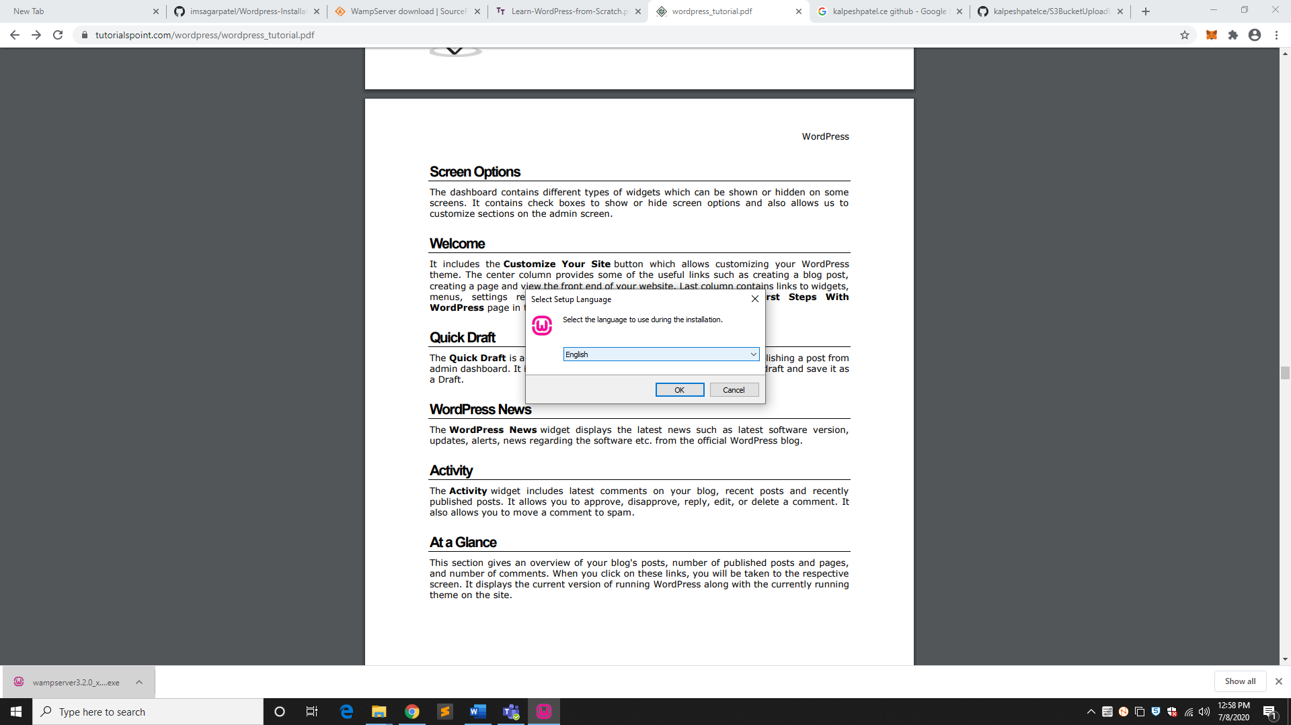

Accept agreement and click on **NEXT**

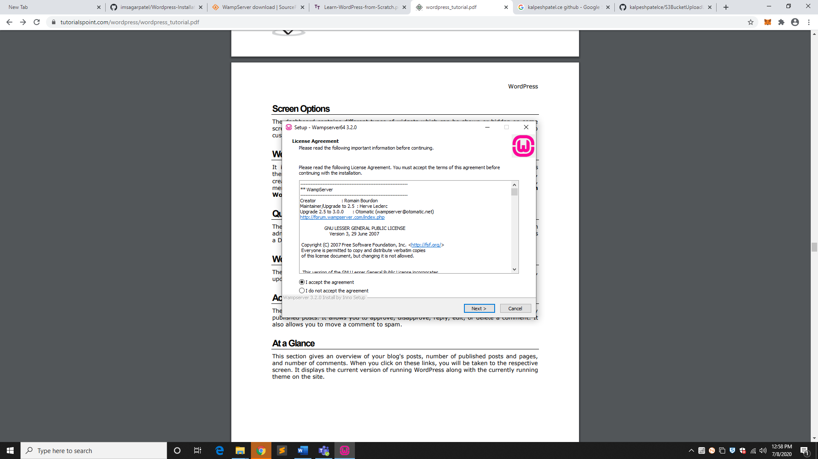

Click on **NEXT**

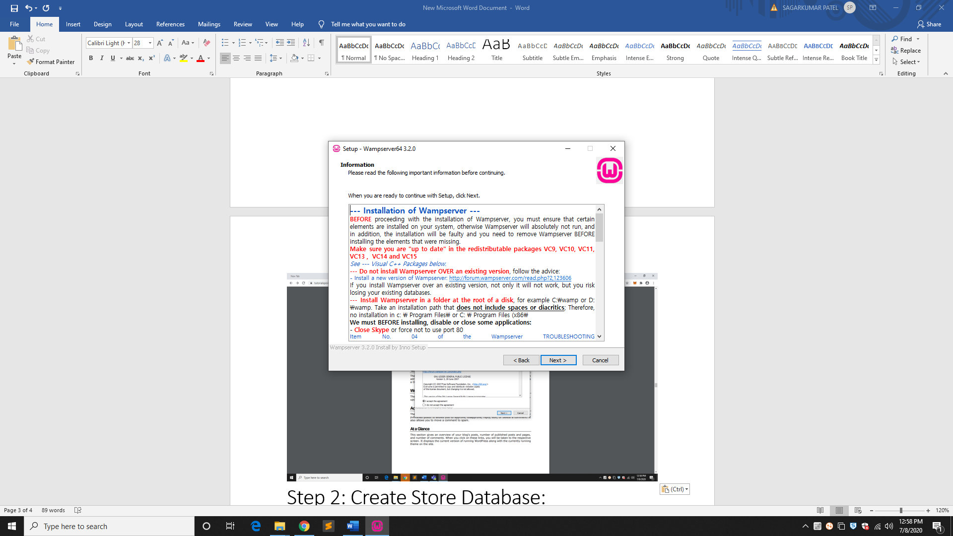

Browse and **select destination location**

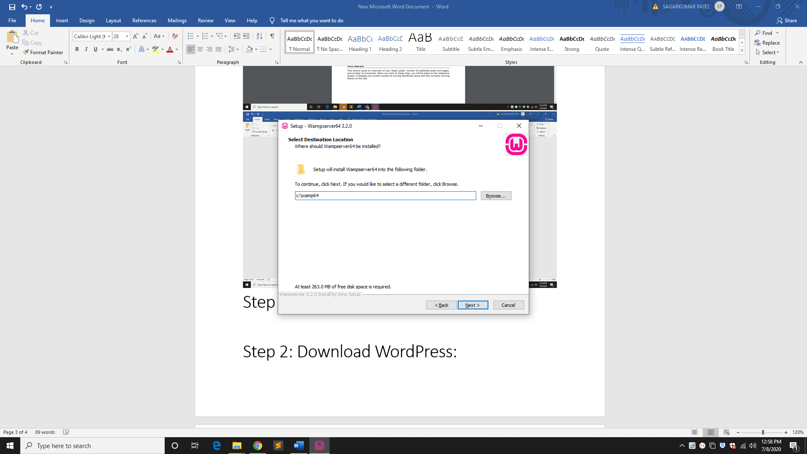

Choose default installation components and click on **NEXT**

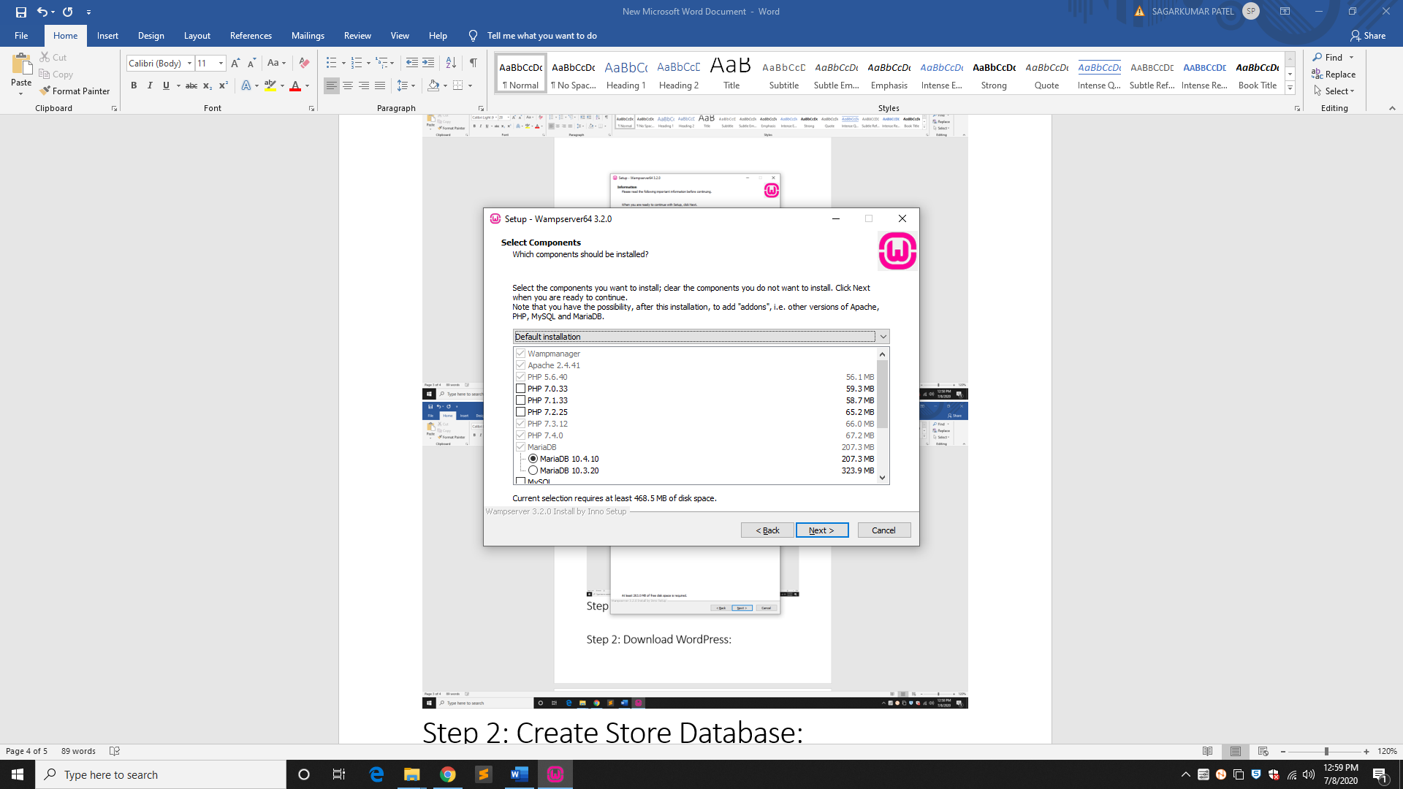

Browse Start Menu Folder location

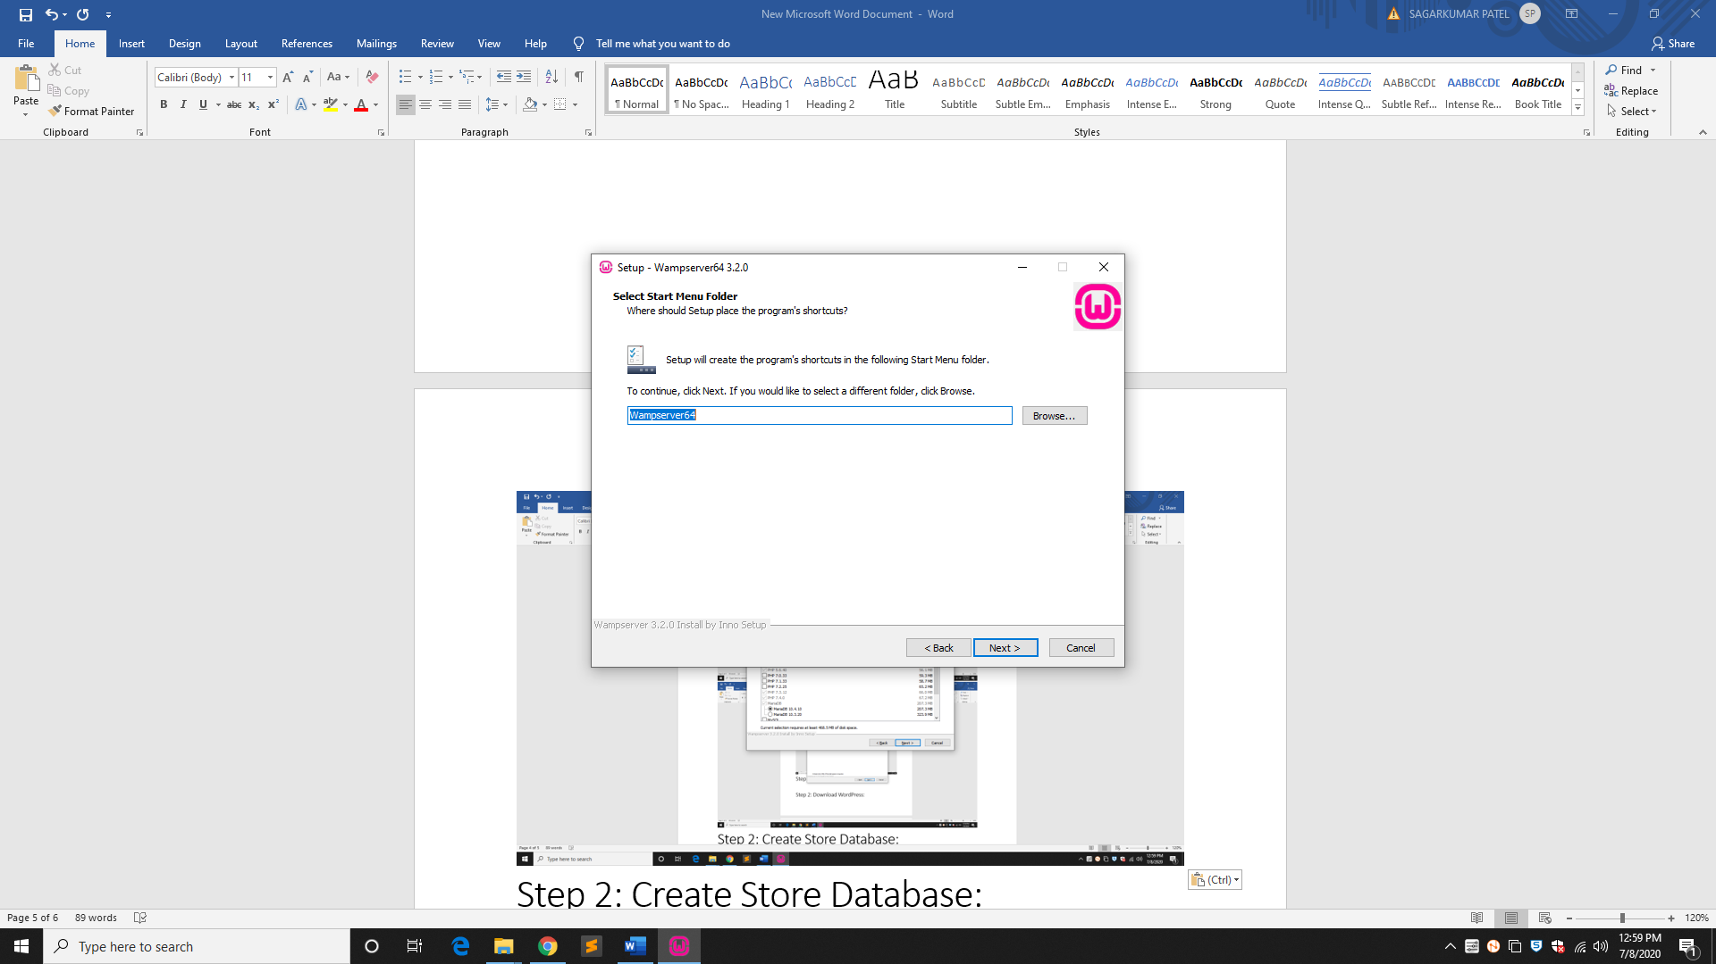

Click on **INSTALL** to complete installation process

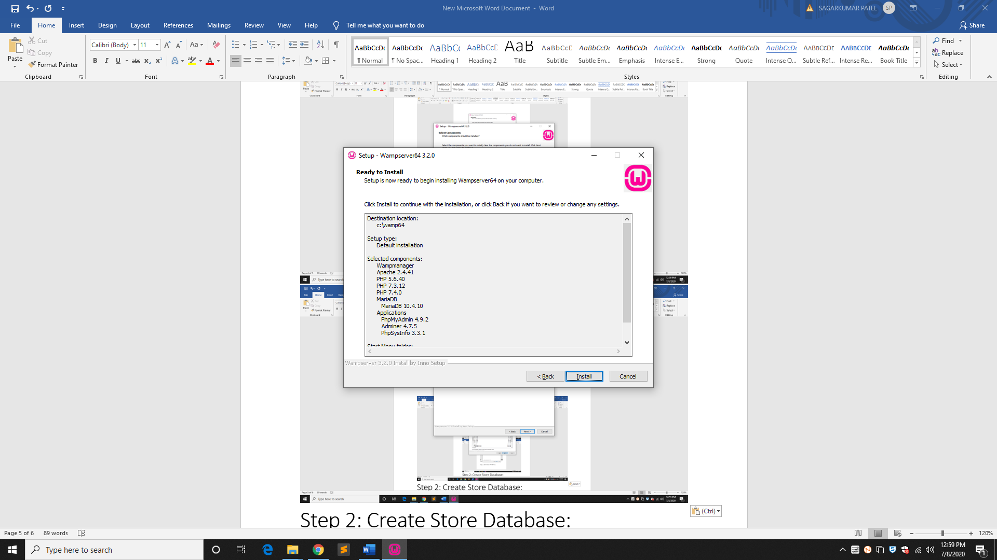

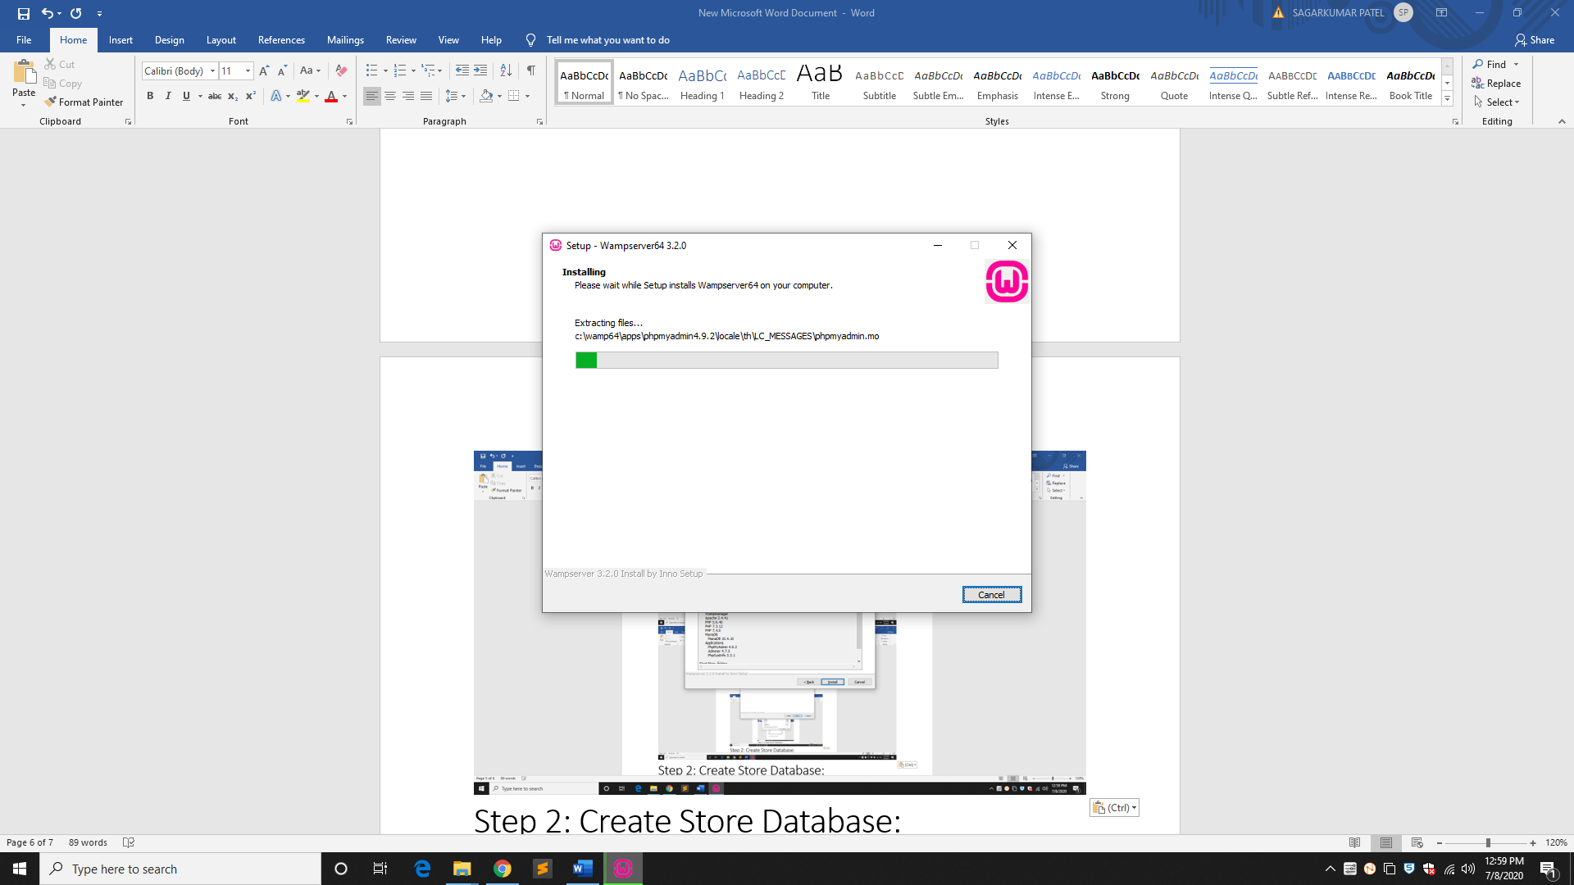

Click on **FINISH** after installation process complete

Download WordPress:

Open the link <https://wordpress.org/download/>

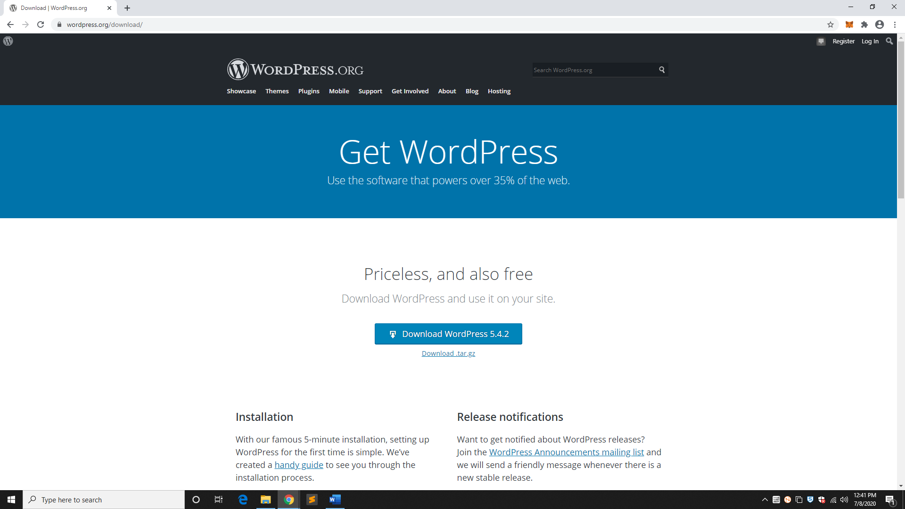

Download the WordPress 5.4.2 zip file from the official site

Create Database into PhpMyAdmin:

**Step 1:** Open WampServer from start menu

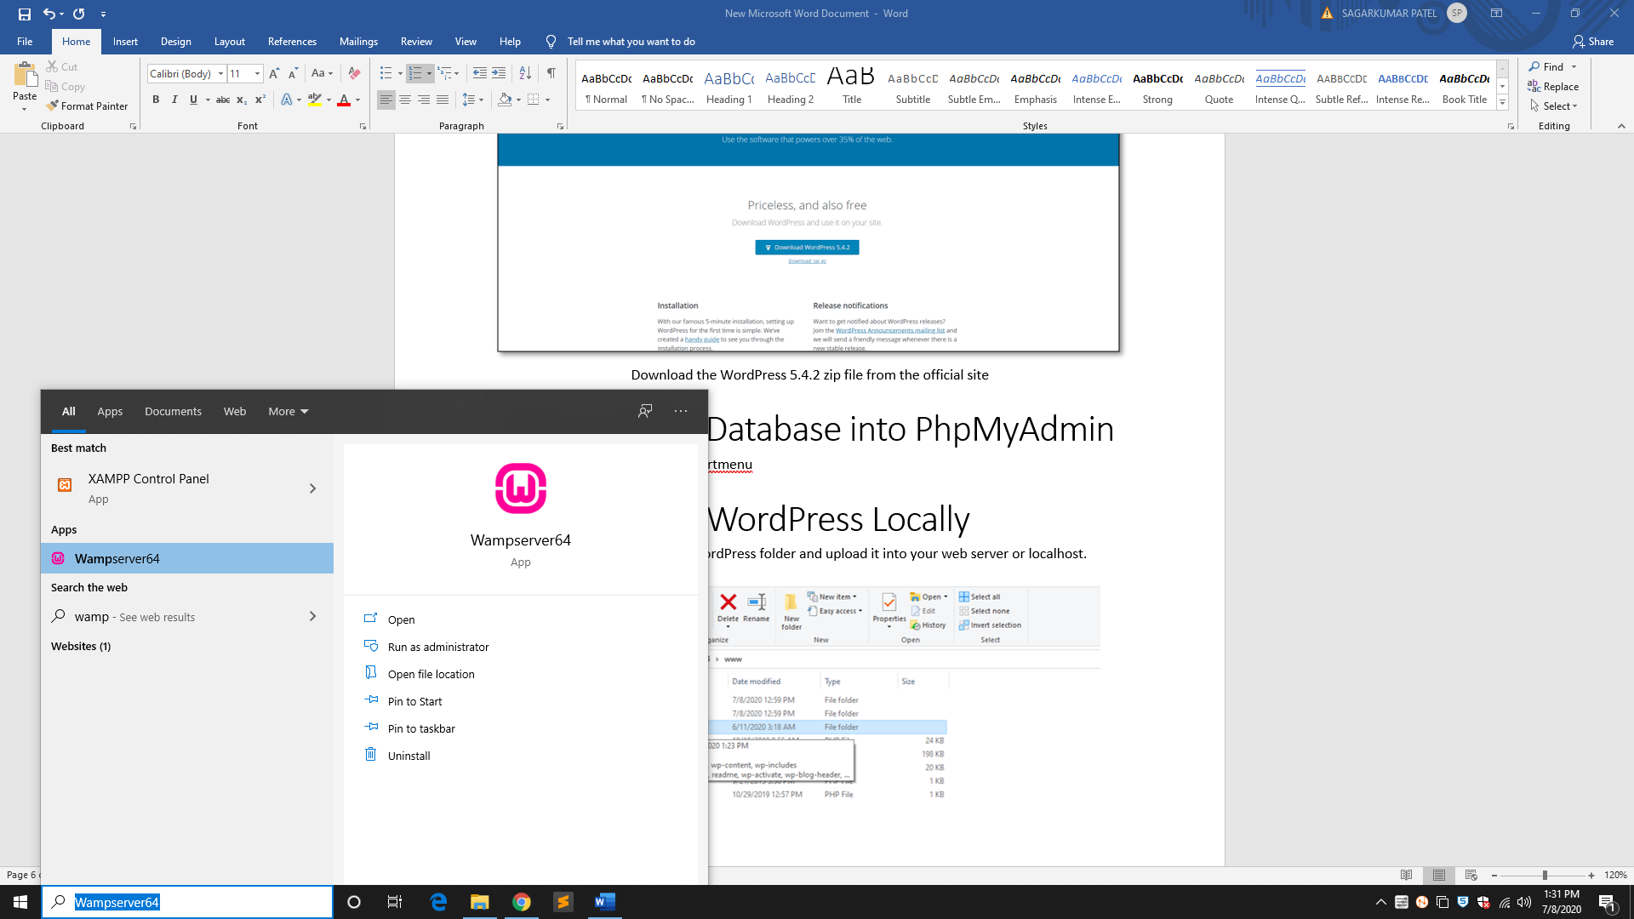

**Step 2:**

In case of error download & install **Microsoft Visual C++ 2010 Redistributable Package (x64) –** [**CLICK HERE**](https://download.microsoft.com/download/3/2/2/3224B87F-CFA0-4E70-BDA3-3DE650EFEBA5/vcredist_x64.exe)

**Step 3:** Wait until green logo appear on the bottom right task bar

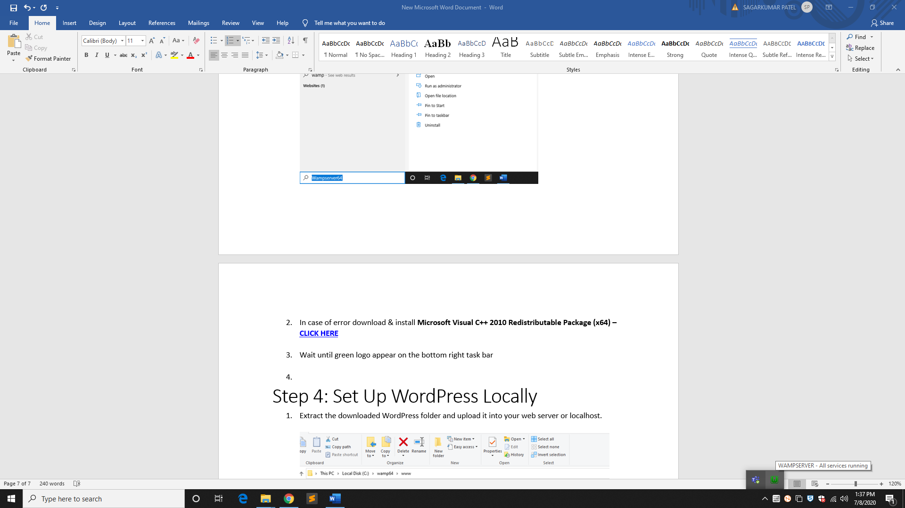

**Step 4:**

Open any of the supported browser and type **localhost/phpMyAdmin** to create database

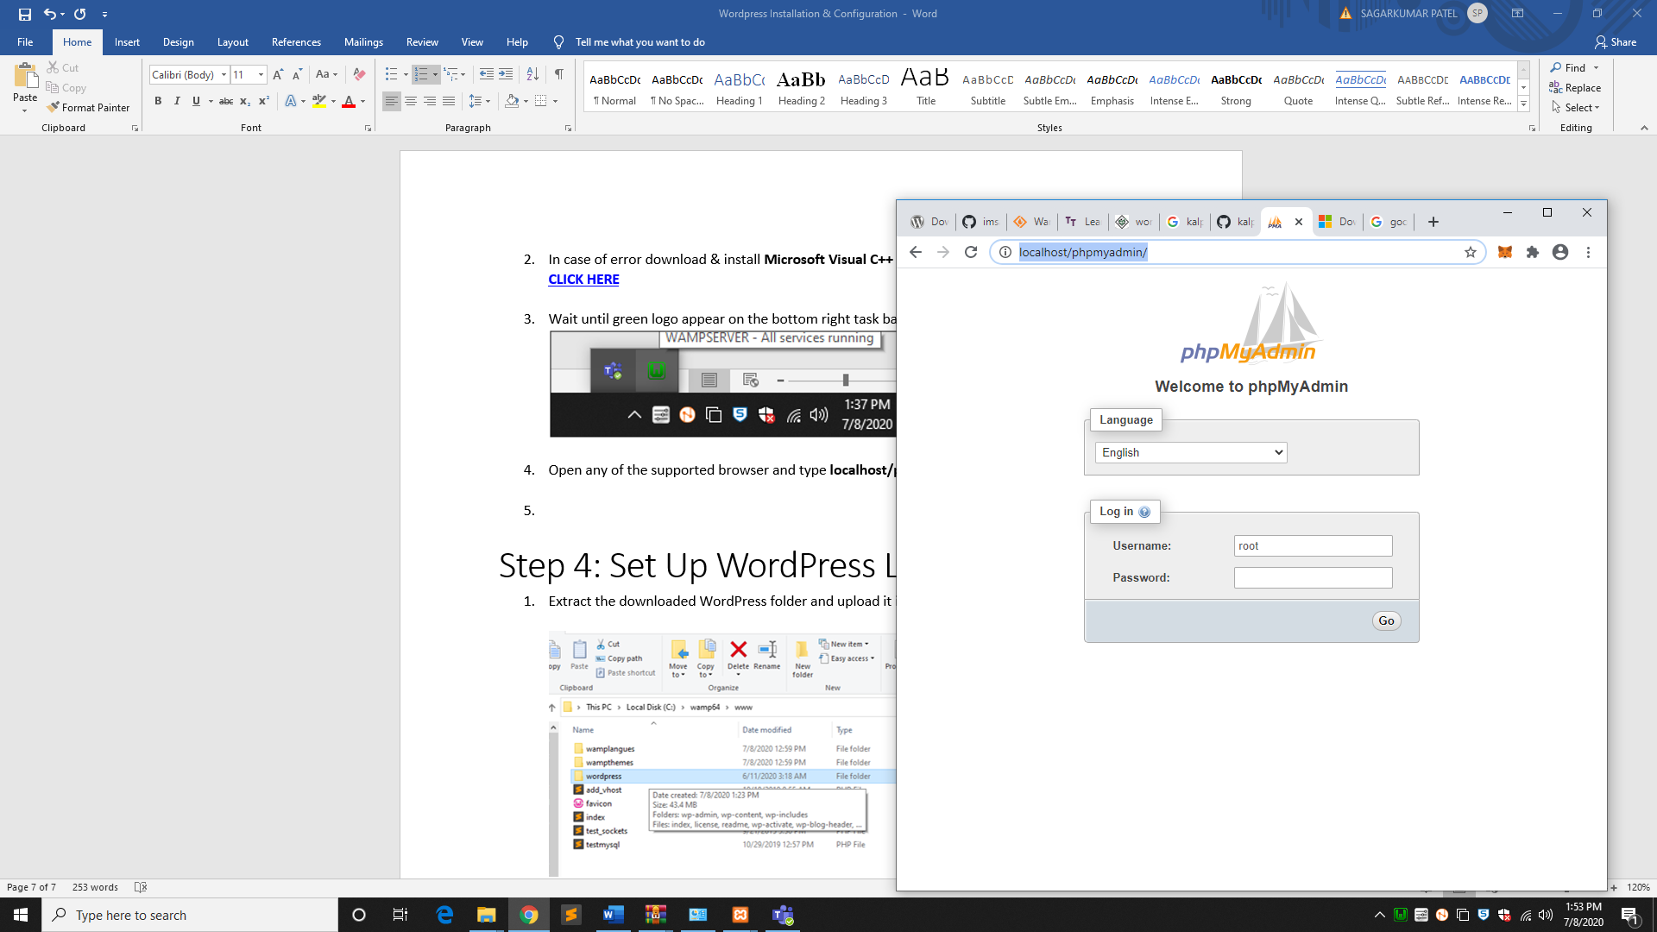

Click on Go button.

**Step 5:** Click on database tab and then enter name of the database.

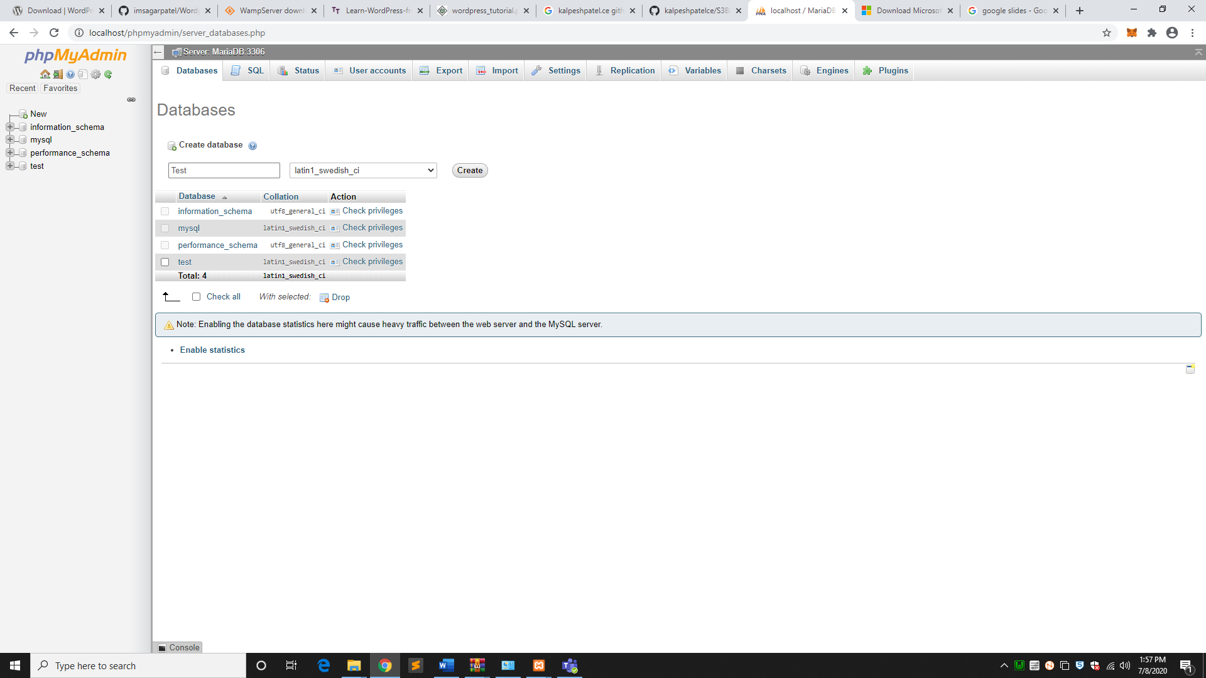

**Database Name:** Test

Set Up WordPress Locally:

**Step 1:** Extract the downloaded WordPress folder and upload it into your web server or localhost.

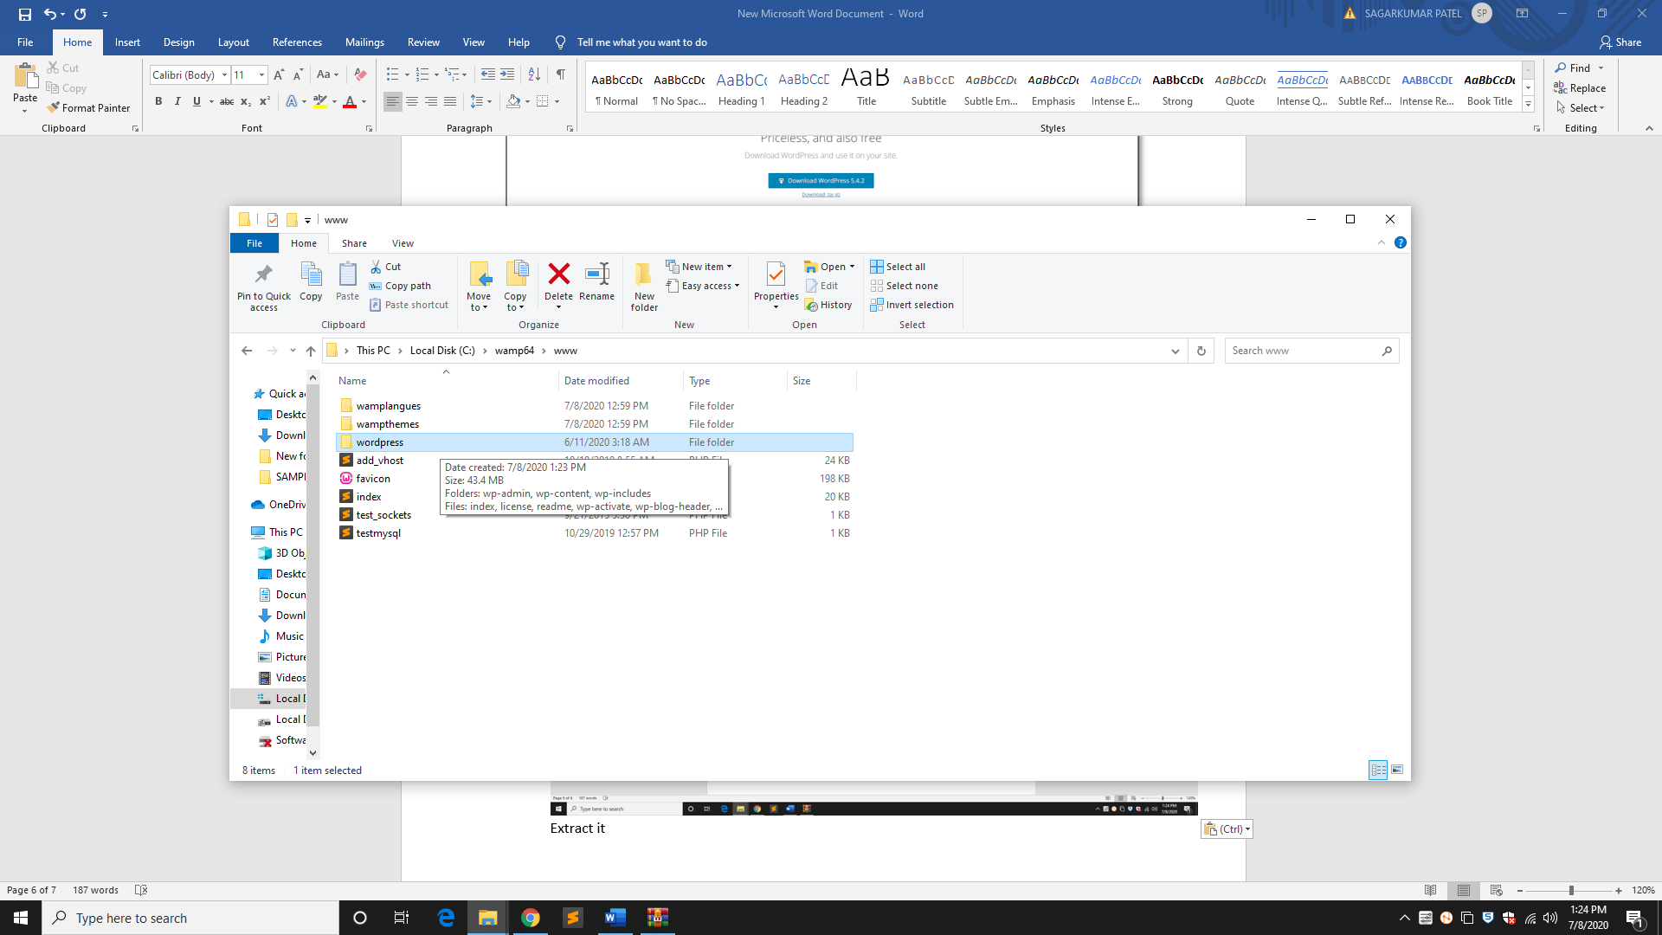

**Extract here:** C:\wamp64\www

* Here www is the root folder of the localhost server

**Step 2:** Open your browser and navigate to your WordPress file path, then you will get the first screen of the WordPress installer as shown in the following screen. In our case, the path is **localhost/< Your_WordPress_folder >.**

**Example:** Localhost/wordpress

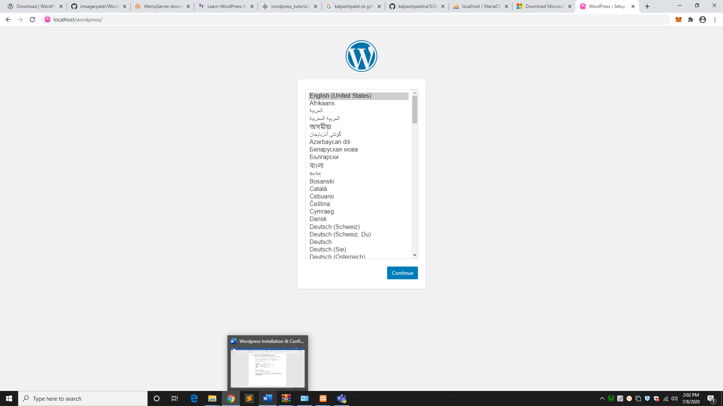

**Step 3:** Select your language for the WordPress and click on **Continue.**

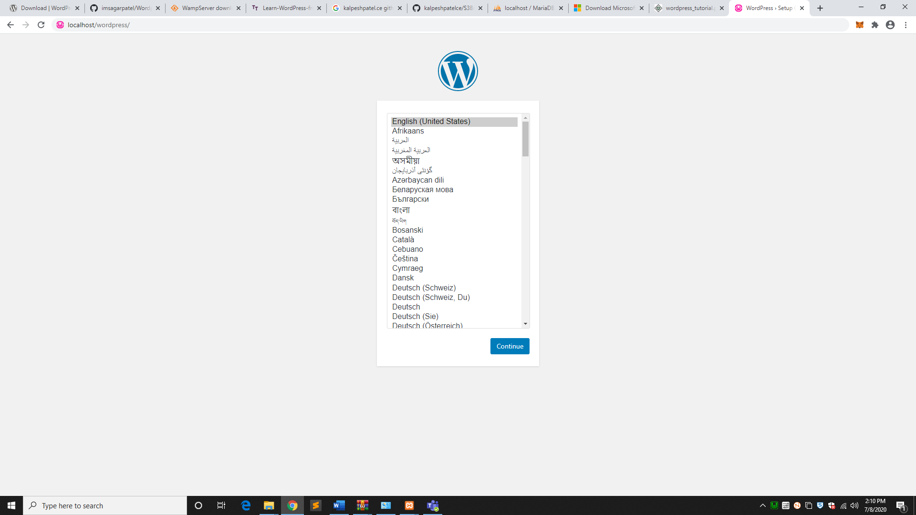

**Step 4:**

In this step, you can view the information needed for the database before proceeding with WordPress installation.

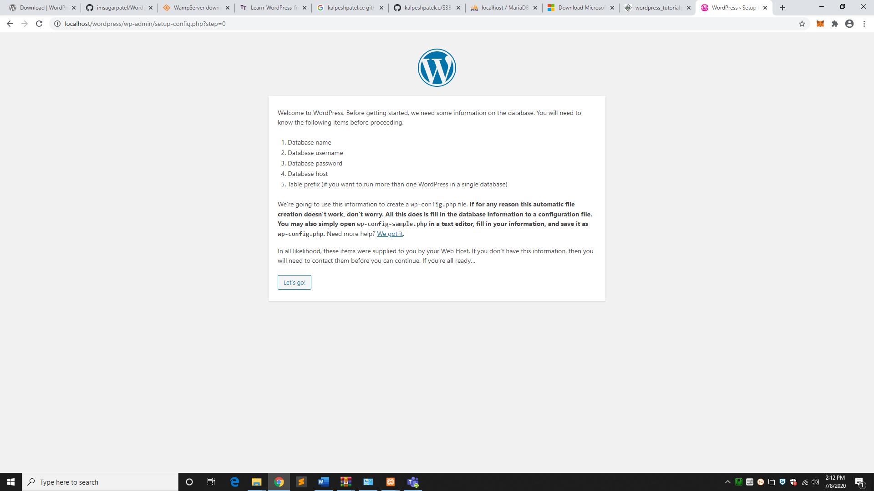

Click on **Let's go!**

**Step 5:** Enter the information about the MySQL database as described in the following screen.

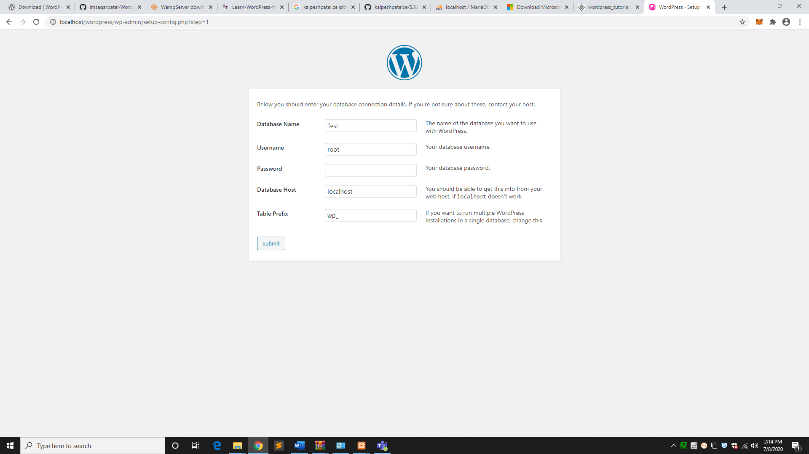

* **Database Name:** Enter the database name which you have created in MySQL database for WordPress.
* **Username:** Enter the user name of your MySQL database.
* **Password:** Enter the password which you had set for MySQL database.
* **Database Host:** Write the host name, by default it will be localhost.
* **Table Prefix:** It is used to add prefix in the database tables which helps to run multiple sites on the same database. It takes the default value.

After filling all information, click on **Submit** button.

**Step 6:** WordPress checks the database setting and gives you the confirmation screen as shown in the following snapshot.

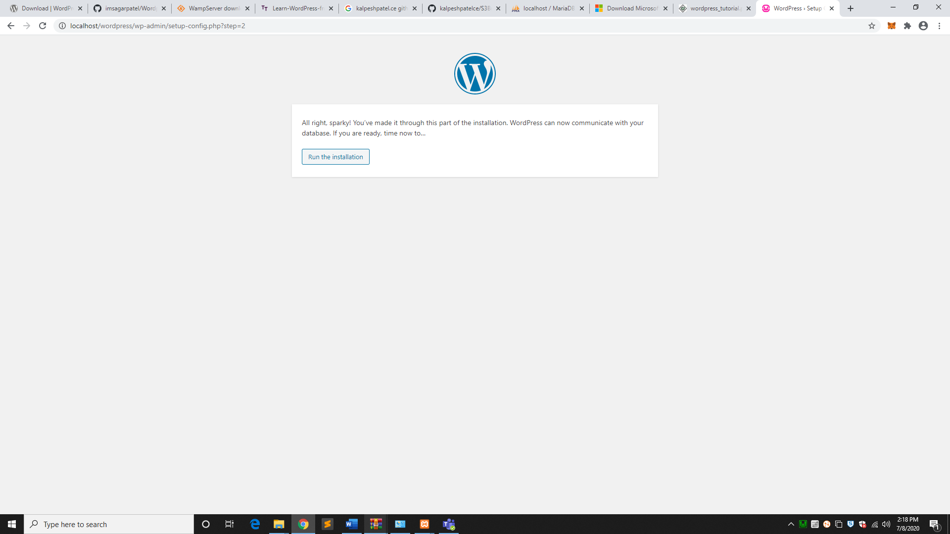

Click on **Run the install**

**Step 7:** Enter administrative information.

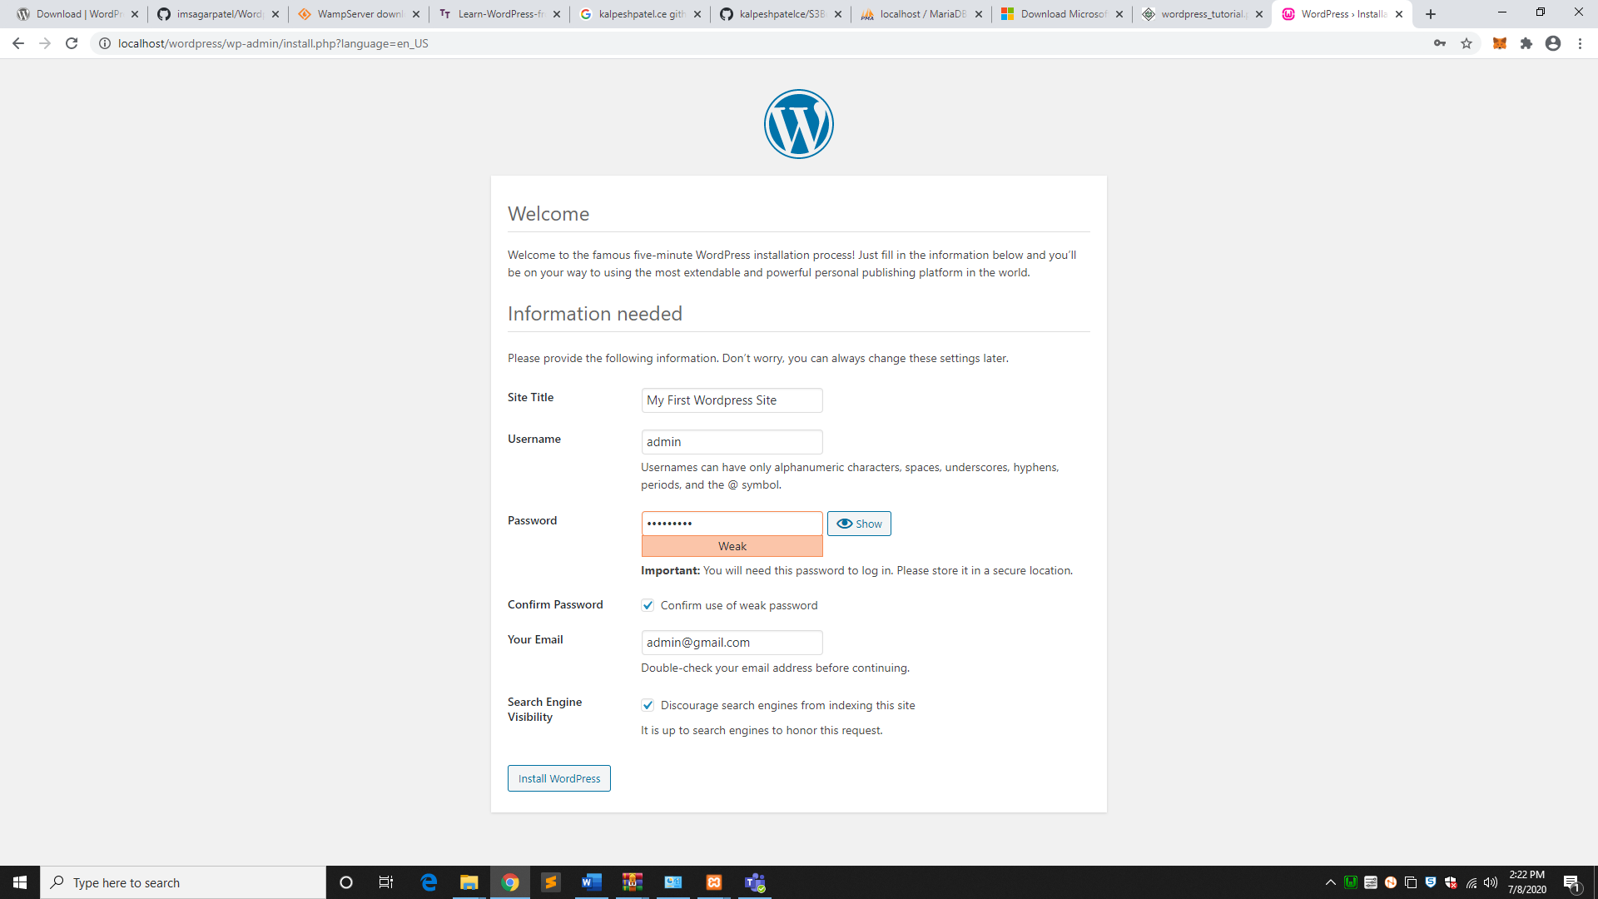

* **Site Title:** Enter the name of the site which you are going to create in WordPress.
* **Username:** Enter the username as per your choice while logging in the WordPress.
* **Password:** Enter password to protect your site.
* **Your E-mail:** Enter your e-mail address which helps to recover the password or any update.
* **Search Engine Visibility:** It allows the search engine to index this site after checking the checkbox

After filling all the information, click on the **Install WordPress** button.

**Step 8:** After installation being successful, you will get a screen of the stating success as seen in the following screen.

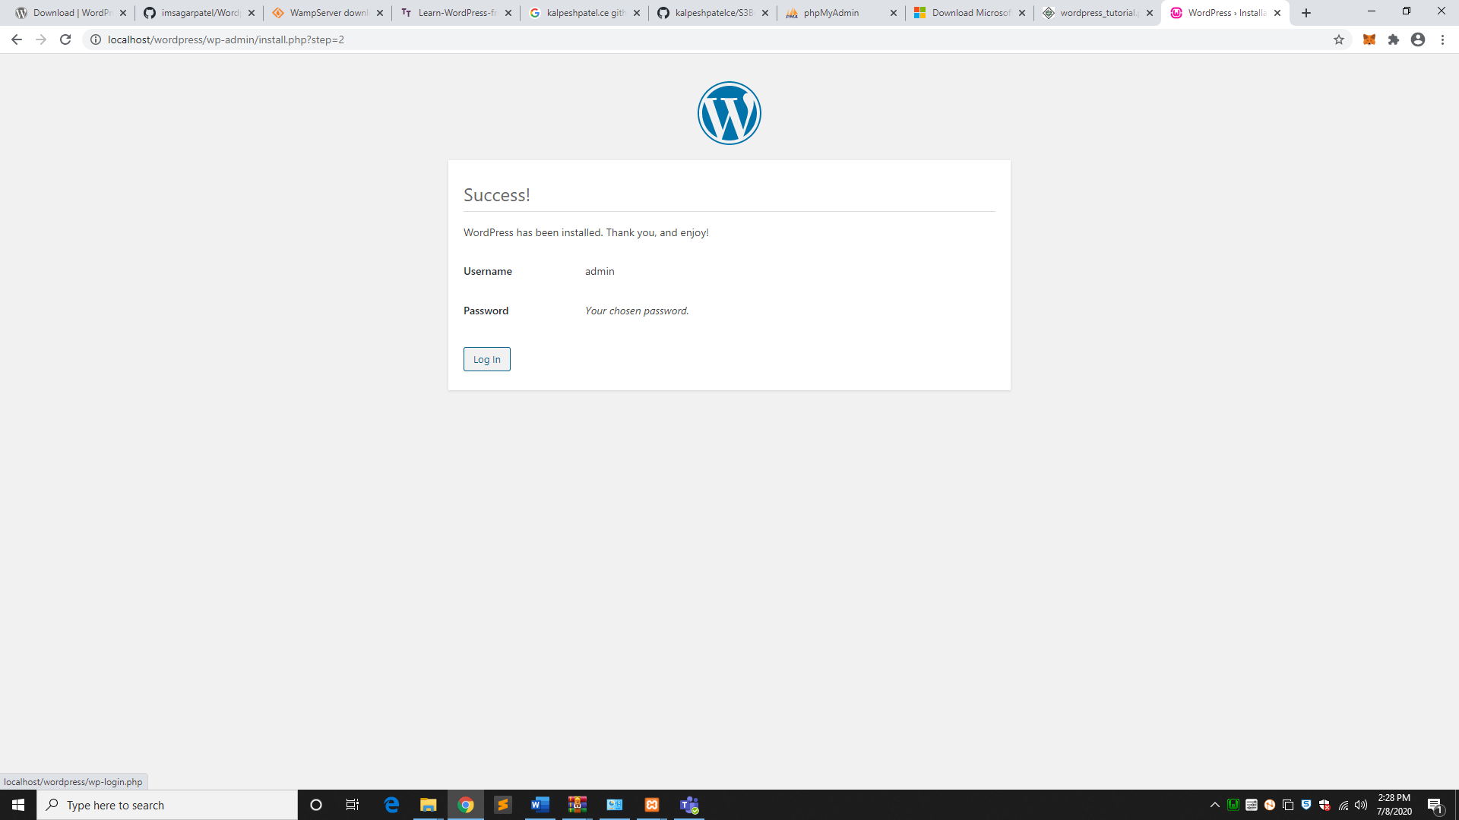

You can view your username and password detail added in WordPress. Click on **Log In** button.

**Step 9:** After clicking on login, you will get a WordPress Admin Panel as depicted in the following screen.

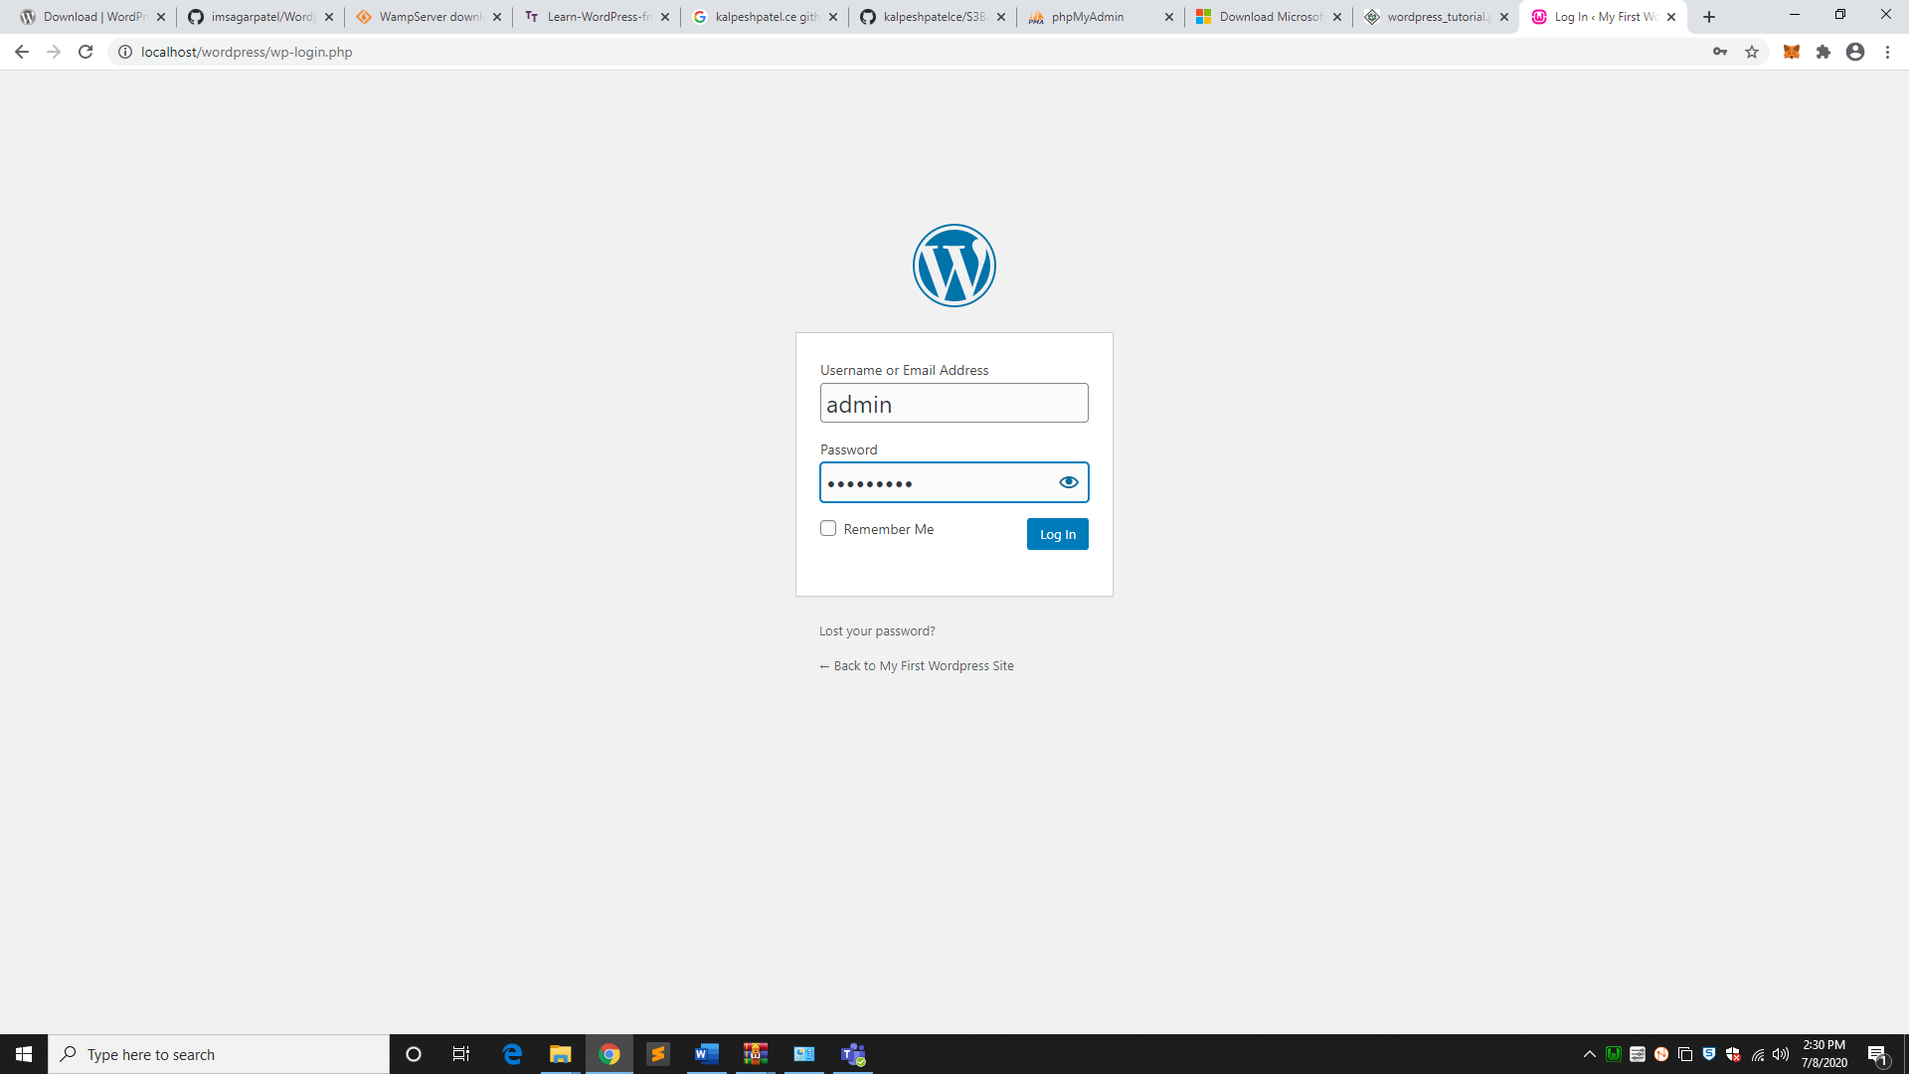

Enter the username and password which you had mentioned during installation as shown in step 6 and click on the **Log In** button.